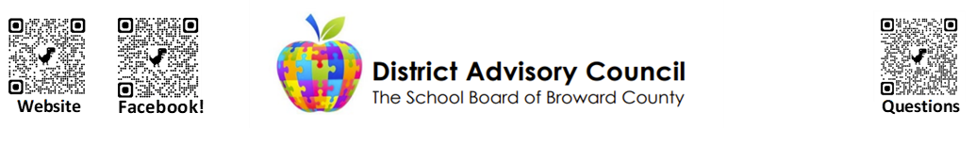

General Meeting Agenda
Wednesday, May 13th, 2026, 6:15 pm - 8:45 pm
KCW Boardroom
600 SE 3rd Ave, Fort Lauderdale, FL 33301

Chair – Cynthia Dominique Vice Chair – Dee Defoe Recording Secretary – Michael Pezzicola Corresponding Secretary – Antoinette Bailey Communications Chair – Brooke Bordy

- Call to order

- Pledge of Allegiance

- Housekeeping:
  - Governance: Policy 1070, Policy 1.2, DAC Committee Bylaws, Florida Sunshine Laws, & Roberts Rules of Order
  - Please remember to sign in. All representatives are required to attend DAC meetings. Missing more than three consecutive meetings or four in a year will result in removal. Failing to Complete Ethics Training results in members not being in good standing.
  - 2025-2026 Meeting Dates:Jun 10 Transition
  - Raise your colored placard to be acknowledged by the Chair in order to speak or vote. We will go around the room once to allow all members an opportunity to speak and then a second round if time permits.
  - Submit additional questions via the QR Code in the upper right corner of the agenda for follow-up
  - Please be respectful. Please be concise with remarks and considerate of time and other members who may wish to comment.
  - Register on our website for reminders & updates https://browarddistrictadvisory.ch2v.com/

- Approval of Minutes: April 8th 2026 Meeting Minutes

- Special Recognitions

- Elections
Executive Board Positions: Chair, Vice Chair, Recording Secretary, Corresponding Secretary, Communications Chair. The Chair and Vice Chair positions must be held by parents of students and may not be employed by the district.
Subcommittees: Elementary, Secondary, Policy, Training and Legislative
Representatives to other Committees: Parent and Community Involvement Task Force, Facilities Task Force, Audit, Calendar, Discipline, Attendance, Technology

- Referendum on Nov 2026 Ballot

- Policy 1070 Recommendations
- Organization Chart Updates

- Committee Reports
  - Student Advisor
  - Areas/Advisories: Central Area, North Area, South Area, Gifted, ESE
  - Subcommittees: Policy, Combination School, Elementary Subcommittee- Testing, Educational Technology, Data Collection and Sharing, Privacy, Privacy Breaches and Data Leaks, and Informed Consent, Computer Literacy and Typing, Emotional/Mental Health, and Recess
  - Other Committees: Title 1, PCITF, Audit, Facilities, Discipline, Attendance, Calendar, Technology

- District Updates- Dr. Veda Hudge, Assistant Superintendent of STO

- Old Business
  - Finance and Budget- Enrollment/FTE Projections, Staffing Allocations
  - Redefining
  - Food and Nutrition Services
  - Coordinated Student Health Services- Hazel HEalth, Consent Forms
  - School Culture and Discipline- Updated Discipline Matrix, Code of Conduct
  - Academics- Syllabi, Testing
  - Safety and Security- SRO Renewal
  - Facilities
  - Information Technology- Acelify communication with Focus is in progress
  - Physical Education

- Important Information for SAF Chairs- School Budget Presentations/Signature, Staffing Allocation Changes for next year, School Improvement Plans for next school year, and elections

- Open Discussion/New Business

- Meeting Reminders
General And Steering Meetings
- Transition Meeting Wednesday, June 10th at 6:15pm-8:45pm at KCW

Elementary Subcommittee
Meeting ID: 233 945 121 615 53 Passcode: Xc9C5bA6

Policy and Bylaws Subcommittee
Meeting ID: 237 156 321 527 30 Passcode: cU6uM352

SAF Chair and Budget Training
- Tentative

- Adjourn

